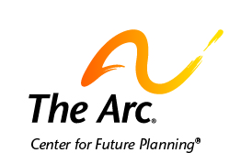

Decision-making

Everybody makes big and little decisions about their life.
We sometimes need or want help to make these decisions.

Many people get advice from people to make decisions.
Some people may receive other help or support to make a decision.

We find people to give us the help we need to make these decisions.
We call this supported decision-making.

Here are some things to think about as you make a future plan.
- What decisions do you want help with?
- What type of help do you want with these decisions?
- Who do you trust and want to help you?

There is no right or wrong answer.
You can get any type of help you want.
You can ask one or many people for help.

Make sure the people you ask know that you are the decision-maker.
They give you the help you want, but you make your decisions.

Sometimes, we ask someone else to make decision for us.
This is called giving someone a power of attorney.

Sometimes, a court decides people cannot make decisions for themselves.
The court assigns a guardian.
A guardian should involve you in decisions.
They should ask your opinion.
They should help you build skills and be more independent.

Contact your protection and advocacy organization:
- if you have a guardian who is not listening to you
- if you need help with making decisions.

You can find your protection and advocacy organization online at http://www.ndrn.org/en/ndrn-member-agencies.html.
You can also call 202-408-9514 to get the contact information.

Contact us if you need more help.
The Arc’s Center for Future Planning
futureplanning@thearc.org
202-617-3268

