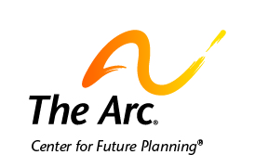

What to Know About Special Needs Trusts and ABLE Accounts

You need to make sure you have money to pay for the things you need.
Talk to people you trust about special needs trusts or ABLE Accounts.
People use these tools to pay for some of the things they need or want.

Special needs trusts can help pay for medical care and service animals.
They can also help you buy assistive technology, phones, and computers.
Money in trusts can pay for car insurance or vacations.

ABLE accounts help people save money for things they need.
ABLE accounts can pay for school, your home, and job training.
They can pay for personal care and food.
They can pay for transportation.
They can pay for someone to help you with finances.
ABLE accounts can also pay for you to talk with a lawyer if you need to.

There are specific ways to set up trusts and ABLE accounts.
People who are setting these up must know the rules about them.
You should talk with family and friends about how to do this.
You can also contact The Arc for more help with how to set these up.

Contact us if you need help.
The Arc’s Center for Future Planning
futureplanning@thearc.org
202-617-3268

