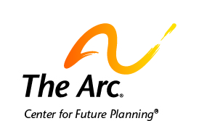

What to Know about Public Benefits

You need to make sure you have money to pay for the things you need.
You can talk to people you trust about this.

One way to pay for things is through public benefits.
Public benefits are money and services from the government.
Some people get public benefits because they have a disability.
Other people get them for other reasons.

Many people receive money from Social Security.
Some people receive Supplemental Security Income from Social Security.
Supplemental Security Income is also called SSI.
Some people receive Social Security disability benefits.
SSI and Social Security give people money.
Many people use this money to pay for clothing, food, and their home.
Social Security has rules about who can receive this money.

Another public benefit is Medicaid.
Medicaid helps people pay for medical costs.
It can also help people get help they need to live in the community.
Each state makes rules about who can get Medicaid.
People often must wait a long time to get certain types of help.

Here are steps you can take to see if you can get public benefits.

- Talk with people you trust about government benefits.
These people may be friends, family, or other people.

- Ask for their help to find out about benefits you can receive.
Visit the Social Security and Medicaid websites to learn more.
Contact your local chapter of The Arc for help with this.

- Apply for public benefits.
People you trust can help you apply for benefits.
Chapters of The Arc or other professionals can also help you apply.

Contact us if you need more help.
The Arc’s Center for Future Planning
futureplanning@thearc.org
202-617-3268

