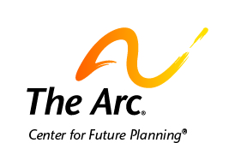

How to Make a Future Plan Your Own

A future plan is all about you.
It is about your skills, interests, abilities, dreams, and goals.
It is also about what help you want and need in your life.

Part of making a plan is thinking about what risks to take.
A risk is when you decide to do something that may not work out.
Things may go well or may go badly.
Making a plan is deciding which risks you are willing to take.

You may get ideas or advice from people you trust about risks.
You should think about what the people you trust say.
Sometimes, the advice you get may make you reconsider taking a risk.
Other times, you may decide to take the risk.

Sometimes, the people we love worry about our safety.
They try to talk us out of doing things that may not turn out well.
When they offer their advice, listen.
Ask what risks they see in your decision.
Ask what bad things they think may happen.
Think about what you would do if those bad things happen.
Afterwards, decide what you want to do.

Sometimes, things do not work out. That is ok.
We all learn from our good and bad decisions.
If you make a bad decision, do not give up on your goal. Make a new plan!

Contact us if you need help.
The Arc’s Center for Future Planning
futureplanning@thearc.org
202-617-3268

