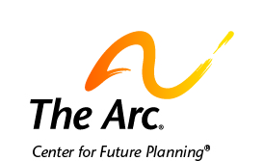

Future Planning

You should make a plan for the future.
Planning helps you do the things you want to do.

A future plan tells the people in your life what you want to do.
It tells them how they can help you do those things.
Future planning tells people about your life right now.
It tells people what makes you happy and how to help you.

Sometimes, thinking about the future can be scary.
But, planning can help you feel better about the fears you have.

Here are some things you can do to start making a future plan.

- Think about who you trust to help you make your plan.
This can be friends, family, or other people you trust.

- Invite these people to talk about the future with you.
Tell them what you want to do in the future.
You can either talk with people one-on-one or in a group.

- Write down any plans you make or things you talk about.
Talk about whatever is most important to you.
You can find a plan you can fill in here:

- Keep meeting and talking about the future.
You should review your plan at least once a year.
You can add or remove things from your plan.

Contact us if you need more help.
The Arc’s Center for Future Planning
futureplanning@thearc.org
202-617-3268

