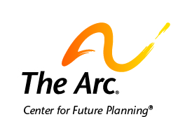

Your Next Home

You may move to a new home one day.
Many people move to new homes several times in their lives.

There are many things to think about when moving to a new place.
You must think about what you want and need the home to look like.
You must think about how to pay for your home.

Here are some things you should think about in a new home.

- Do you want to live with other people or by yourself?
- Do you want to live in a busy or quiet place?
- Do you want to be near public transportation?
- Who or what do you want to live near?
- What help do you need to live in this home?
- What help do you or your friends need to get around the house?
- What technology do you want to have in your home?
- How much money do you need to pay for this home?
- How much money you need to pay for the help you want?

You do not have to know all the answers right now.
But, you should think about what is important to you in a new home.

You can start looking at homes once you know what is important to you.

You can start looking by getting help from people you trust.
These may be your family, friends, or other people.
You may also want to contact a chapter of The Arc for help.
These people can help you visit places to live.
They can help you think about how to pay for a new home.
They can help you think about what is important in a new home.

Contact us if you need more help.
The Arc’s Center for Future Planning
futureplanning@thearc.org
202-617-3268

